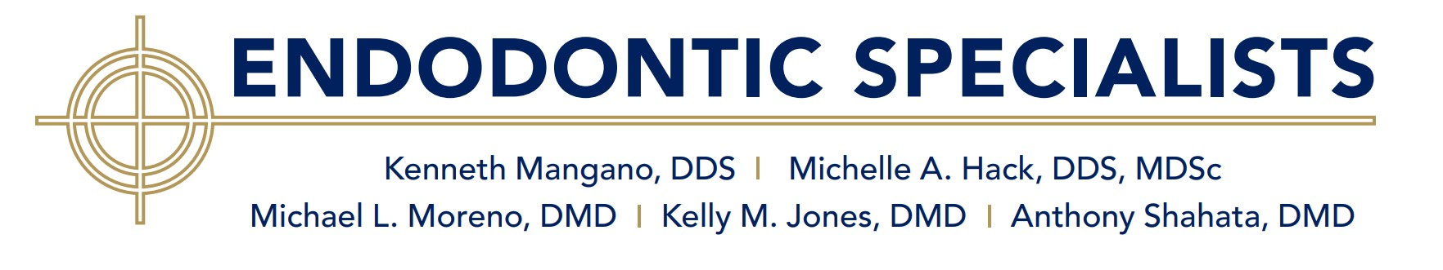
Following your surgery, you can expect swelling in the area. Occasionally there may be some slight bruising as well. It may be more pronounced on the second day after surgery. Most patients report only mild to moderate discomfort in the area.

Generally, ibuprofen (i.e. Advil, Motrin, or generic ibuprofen) is a good starting point for pain management. We strongly recommend that you take 600mg (three over-the-counter 200mg tablets) of ibuprofen every six hours for two days (unless you have an allergy or sensitivity to ibuprofen or have been advised not to use it).

If the ibuprofen alone does not provide adequate pain relief, we have also prescribed a narcotic (i.e. hydrocodone or oxycodone) that can be used as directed (generally 1-2 tabs every six hours) in between doses of ibuprofen.

If you prefer to avoid the narcotic medication (hydrocodone, oxycodone), but still have some pain not controlled by ibuprofen, you may take up to 650mg of acetaminophen (i.e. two regular Tylenol tablets) every six hours in between your doses of ibuprofen in place of the narcotic.

If an antibiotic was prescribed, take all of the pills as instructed, unless you experience complications (i.e. rash, diarrhea, etc.).

Use cold packs for 15minutes on and 15 minutes off for 8-10 hours immediately after the surgery. This will be comforting and greatly reduce the post-operative swelling and help control any minor bleeding.

Beginning 24 hours post-op: rinse or swab the affected area and stitches two times per day with the Peridex mouthwash if prescribed. You can also use warm saltwater rinses 3-5 times a day if this is comforting.

Do eat soft nutritious food. Yogurt, eggs, soups are some good choices. Avoid biting into hard food such as apples or bagels with the teeth in the area of the surgery as this can dislodge the surgical flap. Also avoid particulate food like seeds, popcorn, or chips that could become impacted into the gums in the surgical area.

Do brush your teeth; just avoid brushing in the immediate surgical area.

We will contact you the day after your surgery to check in or leave a number where we can reach you.

DO NOT exercise or do a lot of talking today, plan a restful day tomorrow as needed.

DO NOT excessively stretch or lift your lips and gums in the area.

If you experience swelling or pain that is not comfortably controlled by the medications prescribed or complications with your medicines, please call the office 410-647-3453 during regular hours. For an after-hours emergency you may contact the on-call doctor directly at 443-517-9618.

Please return to have your stitches removed:

Date: Time:

